Chapter 1: The Story of Money - From Barter to Bytes
Long before coins and cards, people traded what they had for what they needed, a fisherman swapped his catch for a farmer’s grain. But barter had a flaw, what if the farmer didn’t want fish that day?
That’s where money was born, a simple tool to make exchange easier.
From cowrie shells and metal coins, to paper notes, and now digital wallets and crypto, money has constantly evolved to match how societies grow and trade.
At its heart, money isn’t just cash or coins - it’s trust.
A shared belief that a piece of paper or a number on a screen holds value because others agree it does.
Today, money fuels everything around us - from the coffee you buy, to the salary you earn, to the investments that build the economy. Banks move it, governments regulate it, and technology now makes it flow faster than ever before.
But while money has evolved, our understanding of it hasn’t kept pace.
We use it every day - yet few truly know how it works, grows, or loses value.
That’s why financial literacy matters more than ever.
When you understand money, you don’t just spend or save - you control it.


Chapter 2: The Next Chapter — The Art of Budgeting
If money is the language of life, budgeting is how you learn to speak it fluently.
Every rupee tells a story - of what you earn, what you spend, and what you value. But most of us never really track that story. We let money come and go without direction, and before we know it, it’s gone - not because we didn’t earn enough, but because we didn’t plan enough.
Budgeting isn’t about restriction - it’s about intention.
It helps you understand where your money goes, and more importantly, where it should go. It’s what separates reacting to expenses from taking control of your finances.
A good budget isn’t just numbers on a screen - it’s a reflection of your goals.
It helps you prioritize what truly matters, build safety nets, and create space for growth.
Whether it’s saving for travel, investing early, or simply cutting back on what doesn’t serve you - budgeting is where financial freedom begins.
Because before you can grow wealth, you need to know how to manage what you already have.
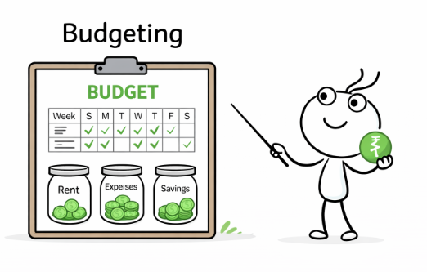

Chapter 3: From Saving to Growing - The Power of Investing
Once you’ve learned to manage what you earn, the next step is to make your money grow.
Budgeting helps you control your spending - investing helps you expand your possibilities.
For most of us, the first lesson we’re taught about money is to save.
We keep it safe in banks, FDs, and feel a sense of security watching it stay intact.
But over time, something quiet happens - prices rise, costs increase, and the same amount of money starts to buy a little less.
That’s where investing steps in.
Investing is how you make your money work while you rest.
It’s not about taking wild risks or chasing quick profits - it’s about ownership, patience, and discipline.
When you invest, you’re putting your money into ideas, businesses, or assets that have the potential to grow.
And in return, your wealth grows with them.
Think of it this way - saving is like storing water in a tank; investing is like channeling it into a field.
One keeps you safe, the other helps you grow something meaningful.
Both matter, but they serve different purposes.
The earlier you start, the stronger your foundation. Small, consistent investments - even modest ones - can build something powerful over time through compounding, where your earnings themselves start to earn more.
Investing isn’t about luck or timing; it’s about understanding and consistency.
It’s about shifting from being a spender to being a builder - someone who lets money create value beyond the present moment.
Because in the long run, wealth isn’t just what you save - it’s what you grow.
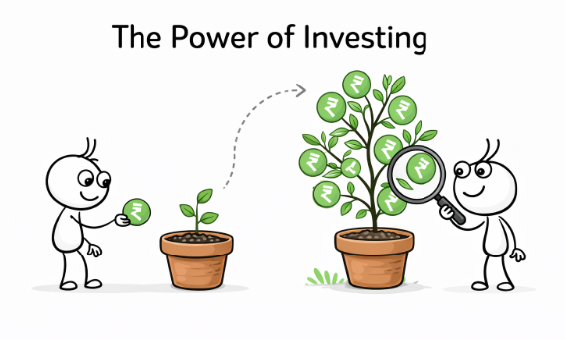

Chapter 4: How to Think Like an Investor
Before you learn where to invest, it’s important to understand how an investor thinks.
Because investing isn’t just about money - it’s about mindset.
An investor doesn’t see money as something to be spent or stored, but as a tool - one that can build opportunities, fund ideas, and shape futures.
Every rupee has potential, and your decisions decide whether that potential grows or fades.
At its core, investing is a blend of patience, discipline, and curiosity.
You don’t have to predict markets or chase trends. Instead, you observe, learn, and play the long game.
You start small, stay consistent, and let time - your most powerful ally - do its work.
Smart investors don’t panic when markets move. They understand that growth isn’t linear.
Like seasons, markets rise and fall - but what matters is staying invested through those cycles.
Because wealth isn’t built overnight - it’s built quietly, through habits that compound.
To think like an investor is to see value where others see price.
It’s to choose understanding over emotion, long-term over instant, and purpose over impulse.
It’s learning that true investing isn’t about getting rich quick - it’s about building freedom slowly and steadily.
The journey begins not with your first investment, but with your first decision to think differently.

Chapter 5: Understanding Investment Options
Now that you know why investing matters and how to think like an investor, it’s time to explore where you can put your money to work.
There’s no single best investment — only the one that fits your goals, risk level, and time horizon.
Let’s look at some of the most common ways people invest and how each helps your wealth grow.

1. Stocks (Equity)
When you buy a stock, you’re buying a small ownership in a company.
If the company grows, your share of its value grows too.
Stocks can deliver strong returns over time but can also be volatile - meaning their prices can rise or fall in the short term.
That’s why stocks are great for long-term investors who can stay patient through market ups and downs.

2. Mutual Funds & SIPs
Mutual funds pool money from many investors and invest it in stocks, bonds, or other assets.
A professional fund manager handles where the money goes.
Systematic Investment Plans (SIPs) let you invest small amounts regularly, helping you build wealth slowly through discipline and consistency.
They’re perfect for beginners - easy, low-stress, and backed by expert management.

3. Bonds & Fixed Income
Think of bonds as loans you give to companies or governments.
They promise to pay you interest at regular intervals.
Bonds are generally safer than stocks but offer lower returns.
They help stabilize your portfolio - a balance between risk and security.

4. Gold & Real Estate
Traditionally, Indians have always trusted gold and property as stores of value.
Gold protects against inflation and uncertainty, while real estate can provide both growth and rental income.
However, both require thoughtful planning - they can be expensive and less liquid (harder to sell quickly).

5. Digital Assets (With Caution)
Cryptocurrencies and new digital assets are becoming popular among young investors.
While they can offer high returns, they also come with high risk and uncertainty.
Before investing, understand the technology, regulations, and risks involved - never invest in what you don’t understand.

Building a Balanced Portfolio
The secret to smart investing is diversification — spreading your money across different types of investments.
That way, if one area dips, another can balance it out.
Your mix depends on who you are - your age, goals, and comfort with risk.
Think of it like your diet: a good mix keeps you healthy and steady.
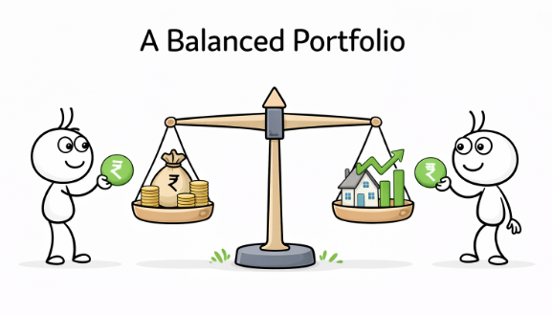

Chapter 6: The Role of Risk and Emotion in Investing
If investing were only about numbers, spreadsheets would make us all rich.
But the truth is - the real game happens in the mind.
Because in investing, your greatest strength or weakness isn’t the market — it’s you.

Understanding Risk
Every investment carries some level of risk - even keeping money idle in a bank means losing value to inflation.
Risk isn’t something to fear; it’s something to understand.
It’s the price we pay for opportunity.
Higher potential returns often come with higher uncertainty, while safer investments usually offer lower rewards.
Smart investors don’t avoid risk - they manage it.
They learn how much they can handle, spread their investments, and let time reduce the bumps along the way.
In the long run, risk isn’t the enemy - impulsive decisions are.

The Emotional Side of Money
Money has a way of triggering emotions - excitement when things go up, fear when they fall.
But reacting emotionally can lead to buying high, selling low, or abandoning plans midway.
Markets move in cycles - optimism, greed, panic, and hope.
The best investors learn to recognize these emotions and stay grounded.
They understand that patience often wins over prediction, and calm over chaos.
When you invest with a plan, emotions become signals - not steering wheels.

Balancing Head and Heart
Being a good investor doesn’t mean being emotionless.
It means being aware.
It’s okay to feel fear when the market dips or excitement when it rallies - just don’t let those feelings make your decisions.
Create a strategy you trust - one aligned with your goals, not your moods.
Review it regularly, but don’t let every headline or tweet shake your conviction.


Chapter 7: How to Start Investing
Every investor, no matter how experienced, began with one simple step - starting.
You don’t need to have it all figured out. You just need to begin with intention, consistency, and curiosity.
Here’s a roadmap to guide your first investment journey.

1. Define Your Goals
Before you invest, ask yourself why.
Are you investing for short-term goals like a vacation or gadgets?
Or long-term ones - a house, retirement, or financial independence?
Your goals determine your time horizon, and your time horizon shapes your strategy.
“If you don’t know where you’re going, any road will take you there.”

2. Understand Your Risk Appetite
Not everyone can handle the same level of risk - and that’s okay.
Some are comfortable with market swings, others prefer stability.
Be honest about how much volatility you can emotionally and financially handle.
Your risk comfort will guide your mix of investments - stocks, funds, bonds, or gold.

3. Start Small, Stay Consistent
You don’t need a huge sum to begin.
Even ₹500 or ₹1,000 a month through a Systematic Investment Plan (SIP) can build serious wealth over time.
The magic lies in consistency, not size.
Regular investing helps you average out market fluctuations and build discipline.

4. Choose the Right Platform
Today, investing is easier than ever.
You can start with trusted investment apps or platforms that allow SIPs, ETFs, or mutual funds.
Focus on ones that are simple, transparent, and regulated.
Avoid anything that promises “guaranteed” or “instant” returns - those rarely end well.

5. Diversify Your Portfolio
Don’t put all your money in one place.
A mix of asset types - equities, bonds, gold, and cash - keeps your portfolio balanced.
Diversification helps protect you when one sector or market slows down.

6. Review, But Don’t React
Once you’ve started, check in on your investments periodically - not daily.
Review once in a few months or at major life milestones.
Avoid emotional decisions during market highs or lows.
Remember: investing is a marathon, not a sprint.

7. Keep Learning
Markets evolve, new products emerge, and strategies change.
Stay curious - read, listen and explore.
The more you understand, the more confident your decisions become.
Because smart investing isn’t about following trends - it’s about understanding yourself and the world around you.

Starting small today is better than waiting for “the right time.”
Because in investing, time itself is the biggest multiplier of wealth.
So take that first step - future you will thank you for it.


Chapter 8: You’ve Taken the First Step - Now Let’s Begin the Journey
You’ve made it this far - and that already puts you ahead of most.
Understanding how money works, how to manage it, and how to make it grow isn’t just education - it’s empowerment.
You’ve learned about the origin of money, why budgeting matters, the importance of investing, and how mindset shapes wealth.
Now it’s time to take that knowledge from your screen to the real world.

The First Real Step: Opening Your Demat Account
Before you can start investing - in stocks, ETFs, or mutual funds - you’ll need a Demat account.
Think of it as your digital vault for investments - a safe, regulated space where your shares are held electronically.
Choose a trusted broker - one you’re comfortable with, one that fits your goals. You could explore platforms like Zerodha, Groww, Upstox, or Angel One to get started.
Because every investor, no matter how successful, began with one small step - the first investment.

Celebrate the Start
You’ve done what most people only plan to do someday - you’ve learned, understood, and now you’re ready to act.
This isn’t the end of your journey.
It’s the moment your journey truly begins.
We’ll be here to help you make smarter decisions, stay consistent, and grow - one step, one rupee, one lesson at a time.
Welcome to the other side of learning - where your knowledge starts creating value.
